Smart Sprayer System on Autonomous Drone with Ensemble Bagged Trees

Alvito Dwinovan Wibowo   
Electrical Engineering Department  
Universitas PadjadjaranSumedang, Indonesia  
[alvito20002@mail.unpad.ac.id](mailto:alvito20002@mail.unpad.ac.id)

Arjon Turnip

Electrical Engineering Department

Universitas Padjadjaran

Sumedang, Indonesia

[turnip@unpad.ac.id](mailto:turnip@unpad.ac.id)

*Abstract- As the world's population increases, the agricultural and food sectors are facing serious problems. It is necessary to increase food production in order to meet the need for food. In an effort to increase agricultural production and efficiency, autonomous drone technology is used for maintenance and watering systems on large areas of land. A smart sprayer system is integrated with autonomous drones. In this research, the smart sprayer system uses the measurement data of altitude, wind speed, and drone speed to determine the watering strength. Watering strength with 3 levels is classified with the proposed Ensemble Bagged Trees (EBT) machine learning method. Experimental trials were conducted for 12 flights with a total dataset of 3750 data. The classification results with EBT obtained an accuracy of 96.1%. This result shows that the proposed technology has the potential to be used as an automatic watering system in agriculture.*.

Keywords— Autonomous Drone, Smart Sprayer, Ensemble Bagged Tree (EBT)

# INTRODUCTION

The agriculture and food sector has been facing many challenges in recent years due to several factors such as increasing world population, limited agricultural land, scarcity of natural resources and climate change.[1] With the increasing population in the world, the need for food will increase. By 2050 it is projected that the world's population will reach 9 billion people which will increase food production by 70% and increase food disposal by 30% of production output [2]. In meeting these needs, there are several problems that must be faced including sufficient food production, proper food distribution, and optimizing the remaining waste [3]. Therefore, it is necessary to increase food production, especially in Indonesia because according to the Central Bureau of Statistics in 2020 there was an increase in the level of food shortages by 8.34%, which increased by 0.71% compared to the previous year [4].

Indonesia is an agricultural country with many people who work as farmers.[5] However, if food production is still carried out in a traditional way, food needs will not be fulfilled.[6][7] Therefore, a solution is needed to increase efficiency for food production[7][8]. One solution that can be done is to automate human work that will simplify and speed up human work. Automation of human work can be done by using autonomous drones or unmanned aerial vehicles[9].

UAVs have the ability to collect information and complete tasks that are difficult for humans to do[10][11]. The advantages of UAVs lie in their ability to be remotely controlled and the ability to work autonomously, so their use can increase work efficiency[11][12]. One popular type of UAV is the drone, which is a remote-controlled unmanned aircraft.

But there are problems in agriculture, namely when it comes time to apply pesticides or watering water on the land. Without drones, the task must be completed by farmers but when the agricultural land is very large, the use of human labor becomes inefficient [12]. This is where drones are needed. Many studies have made watering systems using drones, but there are still very few studies that use pixhawk flight controllers and raspberry pi to make drones spraying on land autonomously and consider several variables so that watering performance increases [12][13]. Therefore, it is necessary to develop an autonomous drone watering system by looking at some of these variables such as the effect of speed, the effect of watering power, and the area of land so that the use of drones can provide even higher effectiveness.

Previously, several studies have been conducted on the use of autonomous drones in agriculture as a watering system. In research [13] drones are used for watering chemicals on pests in coconut fields with remote control for take off, landing, and maneuvering. Then for the microcontroller used is arduino which functions to control the drone motor based on commands that come out of the remote control. Arduino also uses a camera to get video when the drone flies. The information is used to turn on watering via remote control. There is also drone research using Arduino UNO to give commands to the water pump (on / off), but the water pump is constantly on from drone takeoff to landing and constant watering strength [14].

In addition, there is also research on drones using controllers from the water pump itself using Arduino UNO which is connected directly to the motor pump. Flight controller PIXHAWK can provide data in the form of coordinate points, from this data Arduino UNO can process it as when to turn on the motor pump. If only using Arduino UNO, the watering strength cannot be adjusted [15][16].

Previous research has shown that drones can be used for watering both in agriculture to increase the efficiency of the watering. However, with the use of remote control and watering systems that cannot be adjusted starting from the watering strength and when the drone will water, it can reduce the efficiency level of the drone itself. Previous research has also not discussed much about the effect of drone speed, land area, and watering strength on the level of watering performance on the drone itself.

Therefore, this research is focused on developing an automatic watering system for autonomous drones. The watering system will be able to adjust when and how strong the watering is by using waypoints and environmental data received by sensors on the drone. In the watering system, a classification learner is used with the ensemble bagged trees method. This research is expected to contribute to finding the most effective and efficient watering system method on drones so that it can be implemented in agriculture.

# Methodology

## Data Collecting

This research was conducted at the Padjadjaran University Basic Science Service Center Field in collaboration with the Bandung Institute of Technology (ITB) and the National Research and Innovation Agency (BRIN). In the field, plots were made that represented the shape of agricultural land. Flight tests were conducted 12 times with 4 types of trajectories and 3 different altitudes. In conducting flight tests there are several variables collected such as altitude, wind speed, drone speed, latitude, and longitude.

In this test, an F450 frame size was used on the drone. Pixhawk 2.4.6 is used as a Flight Controller (FC) which functions as a controller for the drone. This drone is also equipped with a Radiolink M8N SE100 GPS Module so that it can find out the location of the drone. The Raspberry Pi 4 microcontroller is used to run the python program in this research which is communicated remotely. DC motor is used for the watering system. The hardware block diagram of smart sprayer can be seen in Fig. 1.

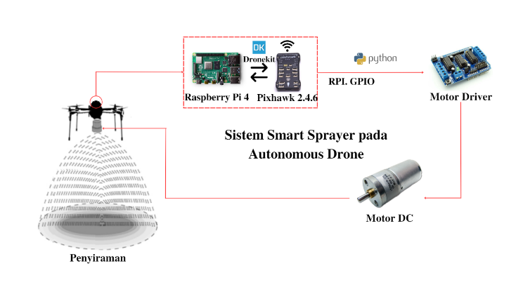 **Fig**. 1. Smart Sprayer System on Autonomous Drone Hardware Block Diagram .

Pixhawk is used to manage drones starting from the drone's command to fly, advance, or land. Pixhawk can also store data from the drone such as altitude data, drone location, and waypoints on the mission. In addition, the Mission Planner application is used for drone calibration or configuration. Mission Planner can also be used to create a mission that will be run by determining the desired waypoint. The waypoint will be the trajectory for the drone and will be passed when flying.

In connecting between Pixhawk as a flight controller and Raspberry Pi 4 as a microcontroller, telemetry and the Micro Air Vehicle Link (Mavlink) communication protocol are used. With the Mavlink protocol, Raspberry Pi can receive various kinds of drone data stored on Pixhawk.

Raspberry PI is used to control the power of watering the DC motor through the motor driver. To connect the Raspberry Pi and Motor, the RPI.GPIO communication protocol is used in the python library by entering the GPIO port in the python program. The DC motor is connected to water storage with a small hose and a watering nozzle. When it turns on the water will be drawn and flow into the watering nozzle. Raspberry regulates the strength of watering by controlling the voltage on the motor driver.

In the watering system, the data used to control the power of watering is altitude measurement data, wind speed, and drone speed. While the data used to control when watering is active is waypoint data on the drone.

The flow chart of the automatic watering system on the autonomous drone can be seen in Fig.2.

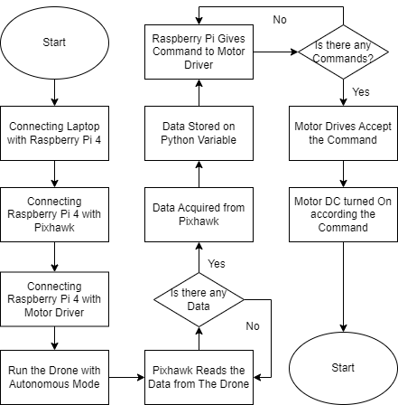

**Fig**. 2. Smart Sprayer System on Autonomous Drone Flowchart .

## Ensemble Bagged Trees

Ensemble method is a combination of several machine learning algorithms to get the final decision so as to provide better performance than using only one classifier. EBT uses a combination of bagging and decision trees techniques. In EBT there are 2 important parts, namely bootstrap and aggregation. In the bootstrap part, several new training data models or subsets are created continuously by sampling and combining data from the dataset. EBT organizes the data into subsets, then the decision trees algorithm is implemented on the subsets. Each subset receives different specifications and variables in the algorithm. For the equation in the bootstrap or bagging stage can be expressed by equation 1.

…(1)

Where fbootstrap is the sum of all models created consisting of (f1)̂(X)+ (f2)̂(X)+⋯(fn)̂(X) where each equation represents the number of models or random subsets created.

Then in the aggregation section is the merging of all the results obtained in each subset by taking the most decisions or voting. Aggregation can solve the problem of overfitting and improve the performance of each decision tree. The algorithm of EBT can be seen in Fig. 3.

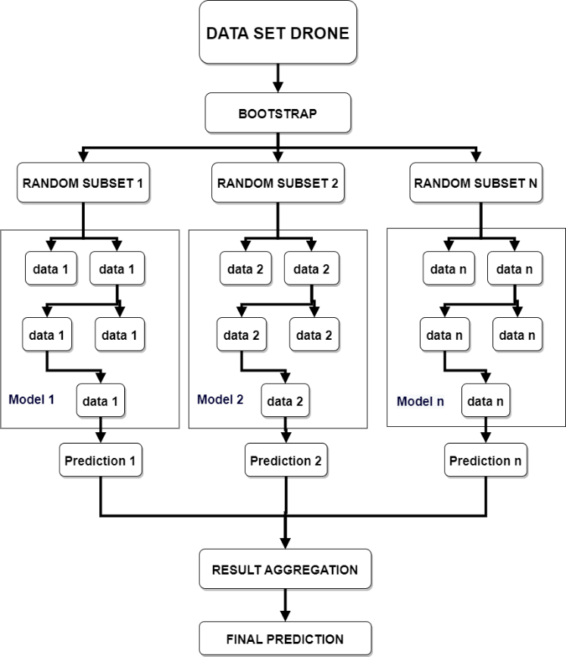

**Fig**. 3. *Ensemble Bagged Trees Algorithm*.

# Result

The data collected into a dataset is in the form of measurement results by sensors where the required data is altitude data, wind speed, drone speed, and GPS error. The experimental dataset amounted to 3750 data with 6 classes namely 0,1,2,3,4, and 5 which means Dead, Very Low, Low, Medium, High, and Very High. Each class has the same amount of data, namely 625 data to avoid unbalancing data. If the data used to train the model occurs unbalancing data, the model will tend to classify into classes with more data. This phenomenon can lead to inaccurate predictions and reduce model performance. The results of the sensor measurements of the smart sprayer drone can be seen in Fig.4 and the dataset description can be seen in Table 2.

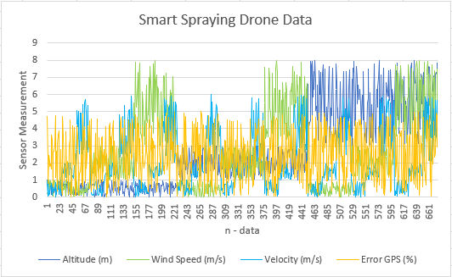

**Fig**. 4. Autonomous Drone Sensor Measurement Data .

**Table** 1.Smart Spraying Drone Dataset Description

|  |  |  |  |  |  |
| --- | --- | --- | --- | --- | --- |
|  | *Altitude*  *(m)* | *WindSpeed (m/s)* | *Velocity*  *(m/s)* | *Error GPS (%)* | *Output* |
| count | 3750 | 3750 | 3750 | 3750 | 3750 |
| mean | 3.8 | 3.73 | 3.01 | 3.74 | 2.5 |
| std | 2.24 | 2.21 | 1.74 | 3.3 | 1.7 |
| min | 0.004 | 0.002 | 0.003 | 0.002 | 0 |
| 25% | 1.87 | 1.88 | 1.5 | 1.5 | 1 |
| 50% | 3.75 | 3.64 | 3.02 | 2.97 | 2.5 |
| 75% | 5.6 | 5.5 | 4.54 | 4.45 | 4 |
| max | 8 | 8 | 6 | 15 | 15 |

In determining the data classification range on the dataset, there are many methods that can be used, but in this experiment, the method used is the Box Plot method. With the box plot, it can see and adjust to the distribution of data based on five summaries (minimum, first quartile, median, third quartile, and maximum), so that the results obtained can be more accurate. The results of the data plot into a data plot can be seen in Fig. 8.

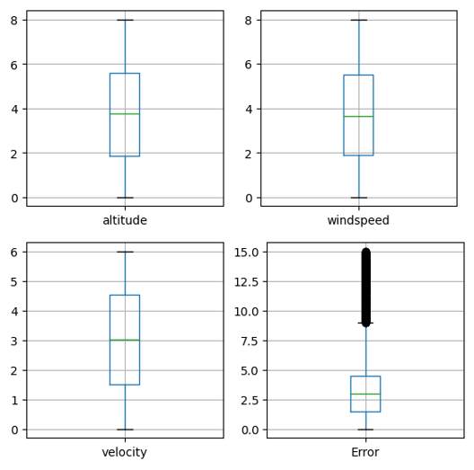

**Fig**. 5. Data Plotting into *Box Chart*

There are two types of variable correlation: negative correlation when the value is <0 and positive correlation when the value is>0, and no correlation when the value is 0. The value can also be seen in how dark and light it is on the Heatmap. The correlation between variables using the Heatmap can be seen in Fig. 6.

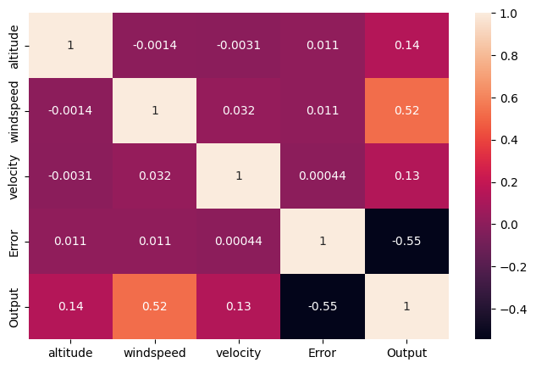

**Fig**. 6. Variable Correlation using Heatmap

The dataset that has been prepared will enter the algorithm creation stage. In making the smart sprayer algorithm, rules are needed to determine the watering strength based on the variables obtained. With the dataset that has been prepared, there are 250 different conditions that will give output when the watering strength will be Off, Very Low, Low, Medium, High, and Very High. The rules of the smart sprayer algorithm can be seen in Fig. 7.

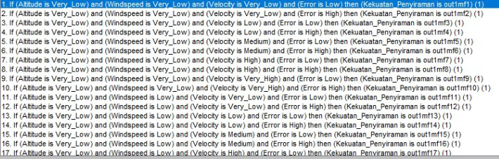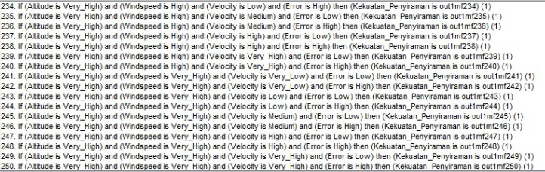

**Fig**. 7. Rules Sistem Smart Sprayer

In this research, an EBT algorithm is created to process the dataset. The features of the dataset and the prediction target are extracted and stored in different variables. The data is then divided into training set and testing set with a ratio of 80:20. The random state parameter is set to 42 to ensure the reproducibility of data division. With the bagging technique, training each decision tree on a random subset of the training data with replacement, and then combining their predictions to make the final prediction. The model of the EBT can be seen in Fig. 8.

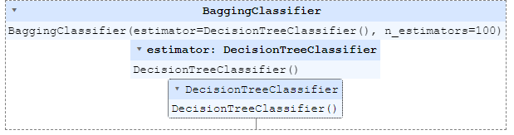

**Fig**. 8. Ensemble Bagged Trees Model Algorithm

Confusion matrix is used to evaluate the performance of the model. In the confusion matrix there are 3 metrics that measure the performance of the model. These metrics are Precision or Positive Predictive Value (PPV), Recall or True Positive Rate (TPR), F1 Score or Harmonic Mean of Precision and Recall, Support, False Positive Rate (FPR), and False Discovery Rate (FDR). Precision measures the accuracy of the model's predictions on the positive class. Recall measures the ability of the model to identify all positive samples. F1-Score is the overall accuracy of the model that combines precision and recall. Support reflects the amount of data tested in that class. FPR is the proportion of negative actual cases that are incorrectly detected as positive by the model. FDR is the proportion of false positive prediction cases to the total positive predictions made by the model. With the model created, the accuracy of the EBT model is 96%. The results of the confusion matrix can be seen in Fig. 9. and the results of metric measurements in Fig. 10.

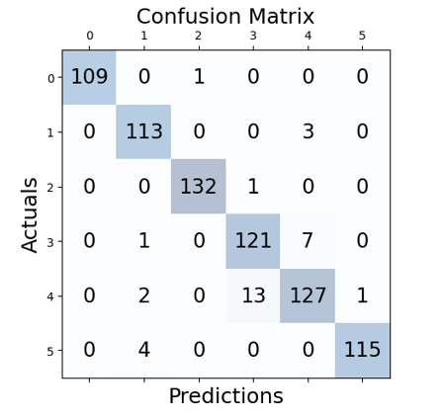

**Fig**. 9. Confusion Matrix Results on EBT

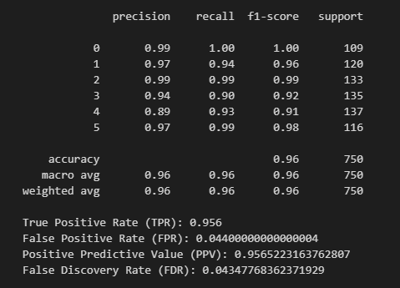

**Fig**. 10. Metric Evaluations Result

# Conclusion

Based on Smart Sprayer experiments on Autonomous Drones that have been carried out. It can be concluded that the classification of watering strength with the measurement results of height sensors, wind speed, and drone speed using the Ensemble Bagged Trees method produces an accuracy rate of 96%. The dataset amounted to 3750 data with 5 classes, each of which amounted to 625 data and the ratio of training set and test set 80:20. In the experiment, there are 5 classifications of watering strength, namely Dead, Very Low, Low, Medium, High, and Very High.

With high accuracy results, the proposed method has potential in smart sprayer systems on autonomous drones. For further research, it can be used on real agricultural land, and components with more sophisticated specifications are used so that the results obtained are maximized.

##### Acknowledgment

This research was supported by the Department of Electrical Engineering, Faculty of Mathematics and Sciences Universitas Padjadjaran, Institut Teknologi Bandung, and Badan Riset dan Inovasi Nasional, Indonesia.

##### References

1. K. Spanaki, E. Karafili, U. Sivarajah, S. Despoudi, and Z. Irani, “Artificial intelligence and food security: swarm intelligence of AgriTech drones for smart AgriFood operations”. Production Planning & Control, 33(16), pp.1498-1516., 2022.
2. W. Jenkins, M.E. Tucker, and J. Grim, “Routledge handbook of religion and ecology. New York: Routledge.”, eds 2019.
3. L. Principato, G. Mattia, A. Di Leo, and C.A. Pratesi, “The household wasteful behaviour framework: A systematic review of consumer food waste”. Industrial Marketing Management, 93, pp.641-649., 2021
4. Badan Pusat Statistik (BPS), “Prevalensi Ketidakcukupan Konsumsi Pangan (Persen),” 2022.
5. Suharto, B., Bambang, et al. "Improving Food Production Efficiency in Agrarian Countries: A Case Study of Indonesia." Journal of Agricultural Economics and Development Studies, vol. 2, no. 1, pp. 29-39, 2018
6. Widyaningsih, W., et al. "Enhancing Efficiency in Food Production for Sustainable Agricultural Development: The Case of Indonesia." Indonesian Journal of Agricultural Economics, vol. 33, no. 1, 2019, pp. 1-17.
7. Utami, H. K., et al. "Increasing Efficiency in Food Production through Technology Adoption: A Study of Indonesian Farmers." Journal of International Food and Agribusiness Marketing, vol. 32, no. 3, 2020, pp. 308-324.
8. Pangestuti, D., et al. "Improving Agricultural Productivity in Indonesia: The Role of Technology Adoption and Infrastructure Development." Journal of Agricultural Studies, vol. 9, no. 2, 2021, pp. 153-167.
9. A. Mosteo, et al., "Autonomous Drones for Industrial Inspection: A Review," Drones, vol. 4, no. 2, pp. 30, 2020.
10. N. Martinez-Carreras, et al., "A Review of the Use of Unmanned Aerial Vehicles (UAVs) for Automated Smart Farming Applications," Drones, vol. 5, no. 2, pp. 38, 2021.
11. N. Roy, et al., "Autonomous Drones for Infrastructure Inspection: A Review," IEEE Access, vol. 8, pp. 128985-129003, 2020.
12. N. Zhang, et al., "Autonomous Drones for Precision Agriculture: A Review," Precision Agriculture, vol. 20, no. 1, pp. 61-82, 2019.
13. A. Hafeez et al.,“Implementation of drone technology for farm monitoring & pesticide spraying: A review,” Information Processing in . Agricultur.,2022
14. C. Widiasari and R. Este Dulan Agustinus S., 2020, “Rancang Bangun Drone Quadcopter Tanpa Awak Penyiram Pupuk Tanaman,” *J. Elem.*, vol. 6, no. 2, pp. 81–90.
15. Duttaroy, S., Nemade, M.U., Devgonde, S., Parmar, V. and Gounder, D., “Efficient Field Monitoring Autonomous Drone (FMAD) with pesticide sprayer and anomaly detection in crops”. 2021
16. L. Jocelyn, R. Karthikeyan, K. Kathirvelan, P. K. Raja, and R. Karthik, 2019, “Enhancing Agricultural Activities using Drone,” no. 3, pp. 3–5, 2019
17. M. S. Saeed, M.W. Mustafa, U. U. Sheikh and T.A. Jumani and N. H. Mirjat, “Ensemble bagged tree based classification for reducing non-technical losses in multan electric power company of Pakistan”. Electronics volume 8, p.860, 2019
18. Y. Himeur, A. Alsalemi, F. Bensaali and A. Amira, “Robust event-based non-intrusive appliance recognition using multi-scale wavelet packet tree and ensemble bagging tree”. Applied Energy, volume 267, p.114877. 2020
19. E. R. Widasari, K. Tanno and H. Tamura, “Automatic sleep disorders classification using ensemble of bagged tree based on sleep quality features. Electronics, volume 9 no 3, p.512. 2020
20. A. Verma and V Ranga “ELNIDS: Ensemble learning based network intrusion detection system for RPL based Internet of Things” In 2019 4th International conference on Internet of Things: Smart innovation and usages (IoT-SIU) (pp. 1-6). IEEE., 2019
21. M. Zounemat-Kermani, O. Batelaan, M. Fadaee and R. Hinkelmann, “Ensemble machine learning paradigms in hydrology: A review. Journal of Hydrology, volume 598, p.126266. 2021